Name_basic

Title_akas

Title_basics

Title_crew

Title_ratings

Title episode

Title principal

stg_numbers_daily_box_office

Staging_Franchises_list

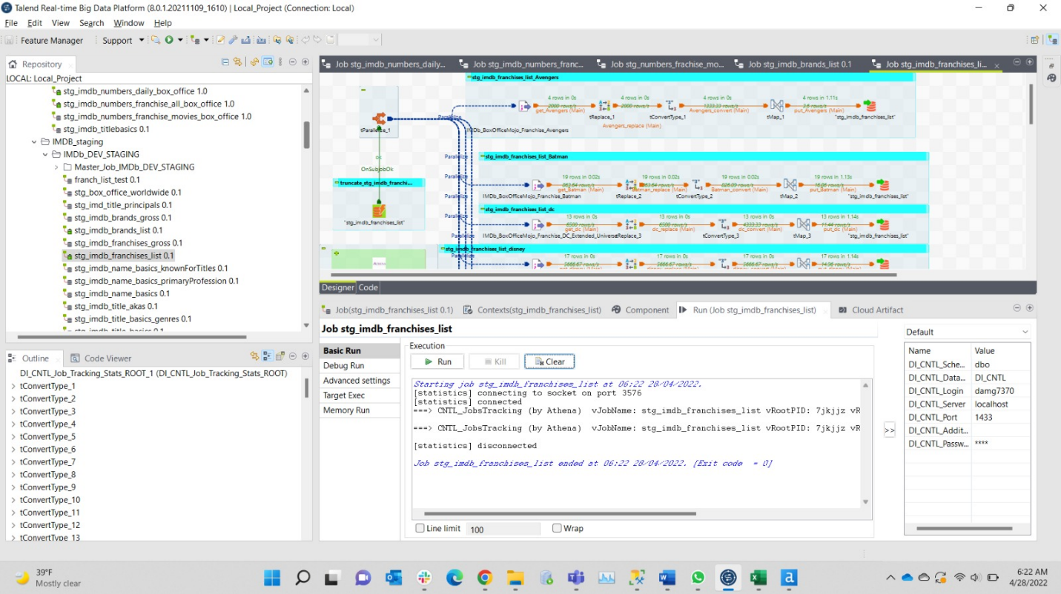

Staging_brand_list

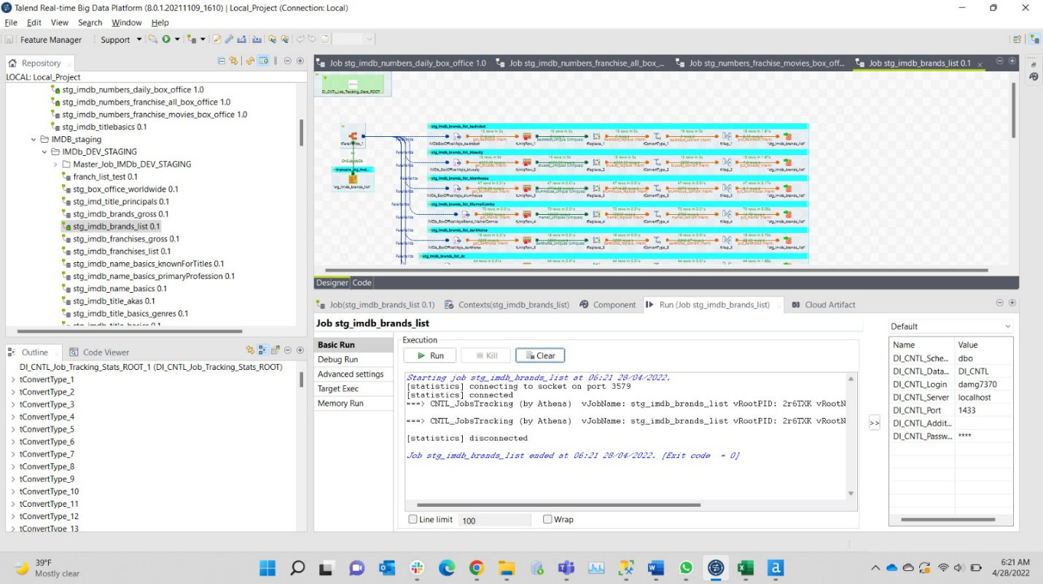

Staging_brand_gross

Staging_franchises_gross

Stage_numbers_daily_box_office

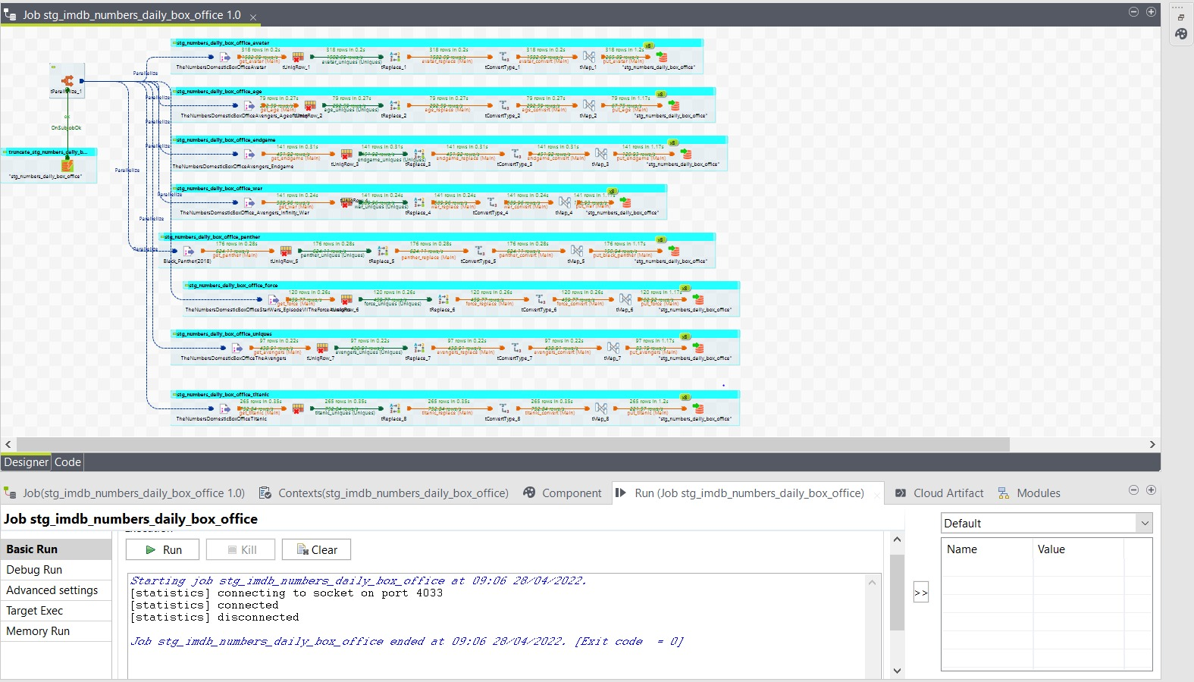

Stage_franchises_all_box_office

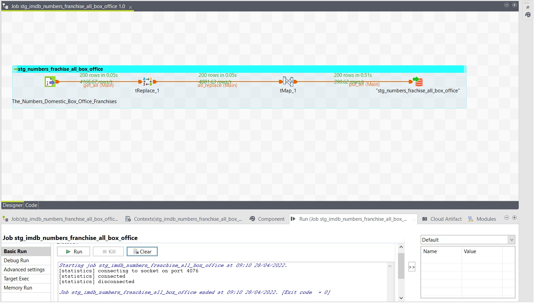

Stage_franchise_movie_box_office

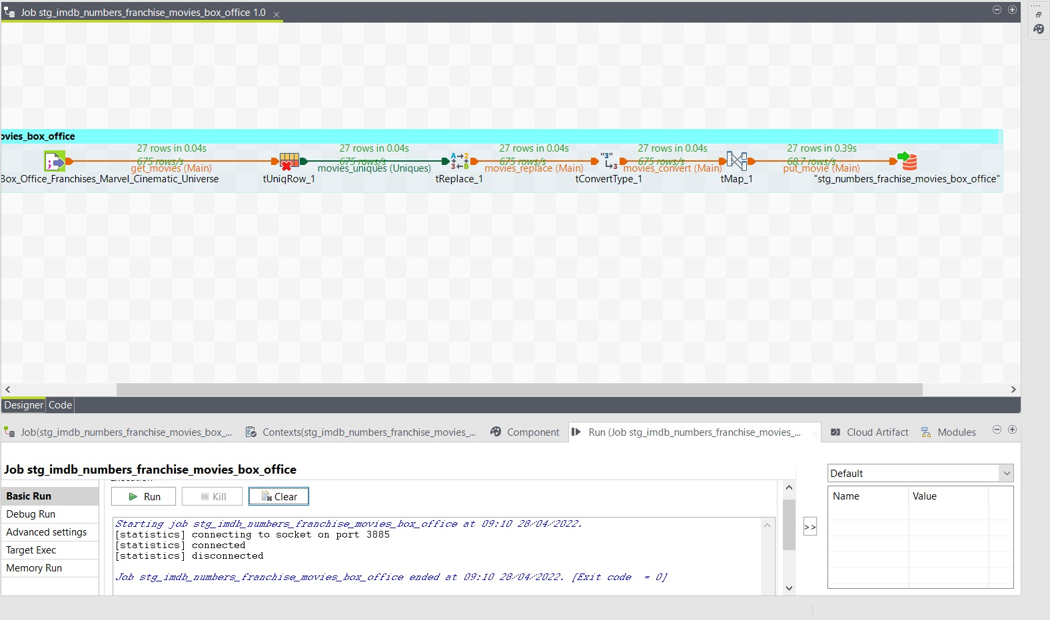

Job run time:DI_CNTL:

SELECT -- query to get Talend job times, you can change where clause of course

job_name,

job_version,

job_status,

Duration_Seconds Duration_sec,

Duration_Minutes Duration_min,

job_start_time,

job_finish_time,

is_root_job,

root_name,

parent_name

FROM [DI_CNTL].[dbo].[job_stats_vw]

where job_start_time >= getdate() -1

order by job_start_time

;

